Electrical Automation Technology, Control Systems Technology & Electrical Systems Design Technology
Performance Test #6, GFCI Receptacle

Name ____________________________ Instructor Verification __________ Grade _________

Material:
Materials Provided by You | Materials Provided by the Department
1. Necessary Tools | 1. GFCI Receptacle
2. 14/2 w/Ground NM-B or MC Cable | 2. Duplex Receptacle
3. Wire Kit

Objective:
Given necessary materials, the student will construct an electrical circuit in 60 minutes, as evidenced by scoring a minimum of 75% on this test.

Description of the Circuit:
Construct a circuit in which the duplex receptacle is protected by the GFCI receptacle. Both receptacles are “hot” at all times. Power is fed to the GFCI receptacle box. All devices are installed in metal boxes.

Time Limit:
You are allowed 60 minutes to complete the circuit. Ten points for every five minutes over the allotted time will be deducted from the score. The maximum overtime allowed is fifteen minutes.

Part 1 (+20 points)
Using a straight edge, draw how this circuit will be wired.
Start Time__________ Finish Time__________

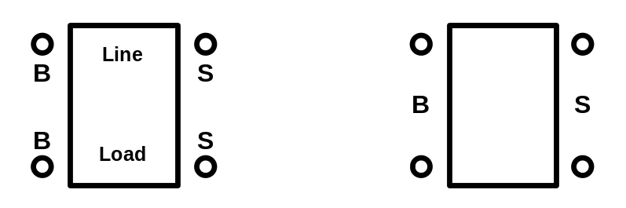

Performance Test # 6

Part #2 (80 points);

Construct the circuit.

____________ Terminated Correctly. +10 points

____________ Correct devices used. +10 points

____________ Installed to NEC. +10 points

____________ 6” of free conductor from the edge of the box. +10 points

____________ 1/4" of cable sheath inside the box and Fittings Tight. +10 points
(if NM-B is used)

____________ All anti-short bushings in place and Fittings Tight. +10 points (if MC is used)

____________ Circuit works as described. +30 points (troubleshooting yourself +15 points)

